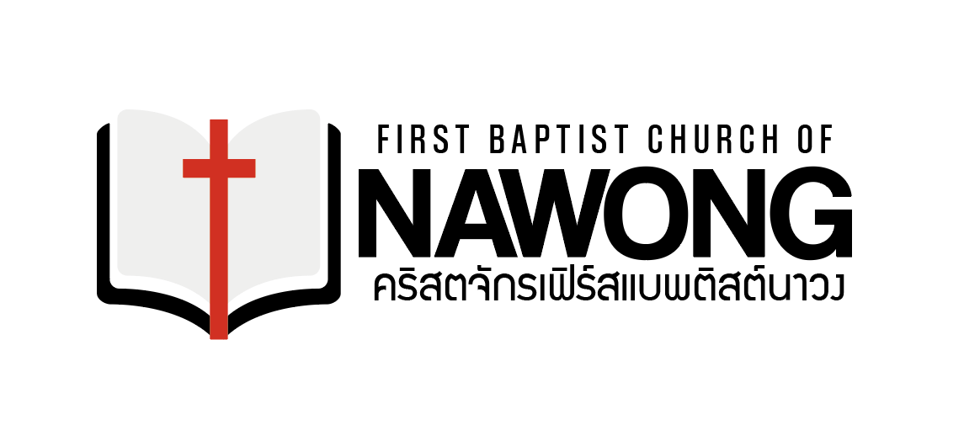

Friends,

Thank you for your continued prayers and support for our ministry. I want to share three things about our ministry.

First, I performed a wedding Saturday, January 18, for 2 of our translators. They have been dating for some time, and through counsel, and God’s Hand, they made the choice to get married. They both serve the Lord with our church and we pray God will use their marriage greatly.

Second, we will renew our 1-year visas on Tuesday, January 28. We are praying for the $800 it costs to renew our visas. We only do this once a year, but it is probably the most important legal act we do all year long.

Last but not least, we are praying for the support for our church planters. We are about $3200/month short for our church planters and we are trying to ask people if they will help us with this very important need.

Thank you so much for praying for us here in Thailand.

May God Bless you.

Eddie Arold and Family

